1. When sorting by a particular column, what does the sortOrder parameter contain?

query string in the URL

1. How does the program tell whether ascending or descending order is being requested?

The case is followed by either an _desc or ascending is pick as a fall thought case

1. What happens in the sorting process when the page is first loaded, and before the user actually changes the sort order by clicking on a column?

The students are displayed in ascending order by last name

1. What method/technique is used to specifiy the column to sort by?

sordOrder

1. When is the query to sort the data actually processed?

.OrderByDescending is used

1. Do a couple screen prints showing the data being sorted by name then date.

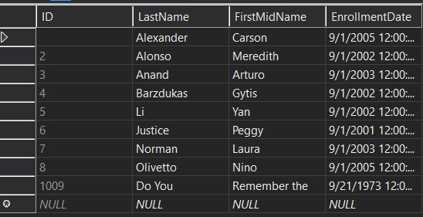

1. When adding filtering capability to limit what rows get displayed to the user, what are the concerns with adding ToUpper to the value being searched for?

SQL Server is case-sensitive

1. When do W3C guidelines suggest using HTTP GET versus HTTP POST when searching?

When in information is sensitive

1. Do a couple screen prints showing a search result of your choice, both found and not found.

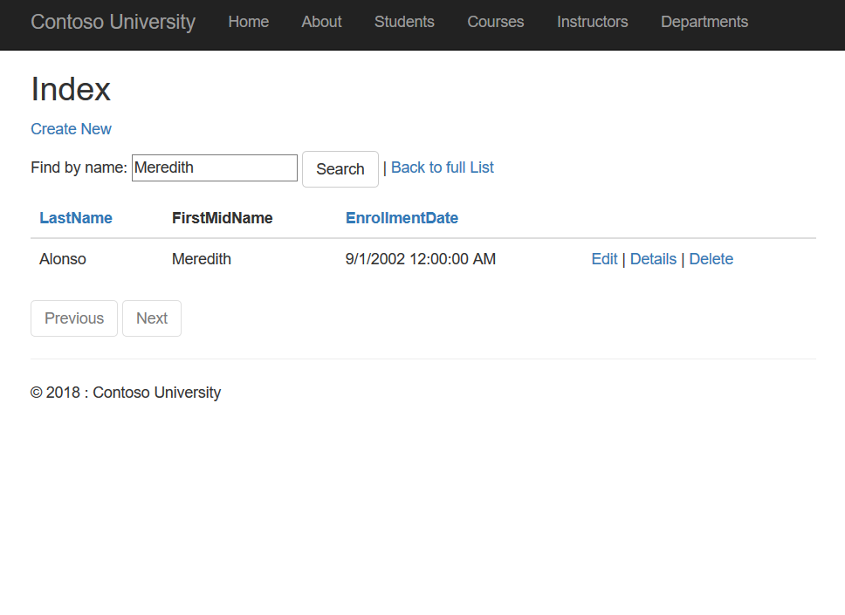

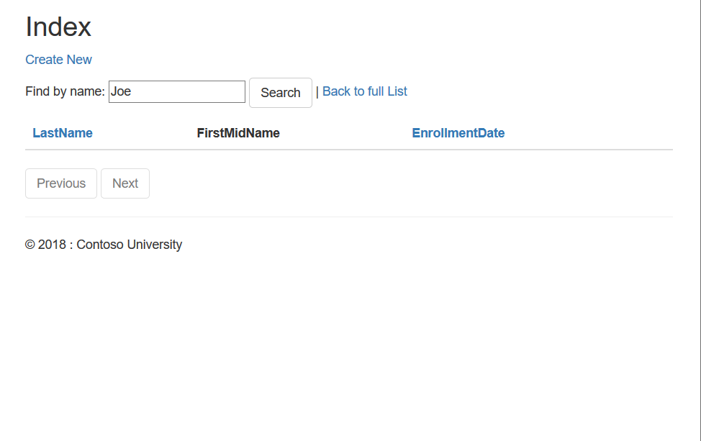

1. What is the null-coalescing operator and what is it’s purpose when paging?

?? defines a default value for a nullable type

1. Do screen prints showing page forward and page previous working, both with and without a filter.

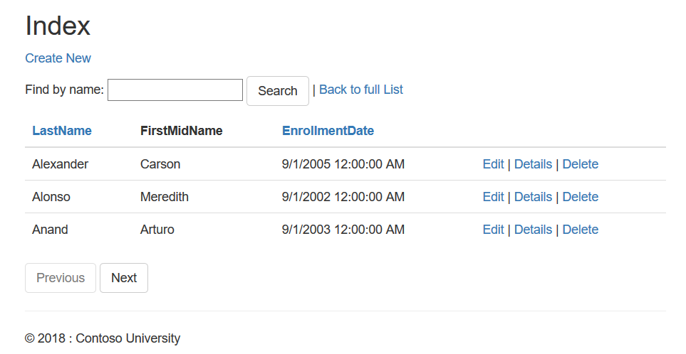

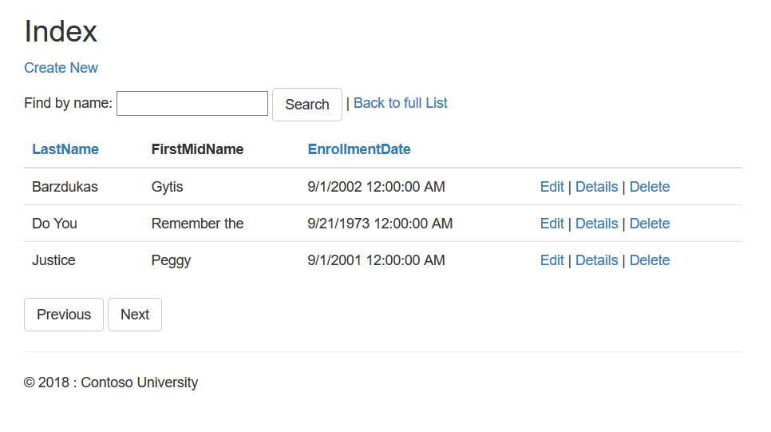

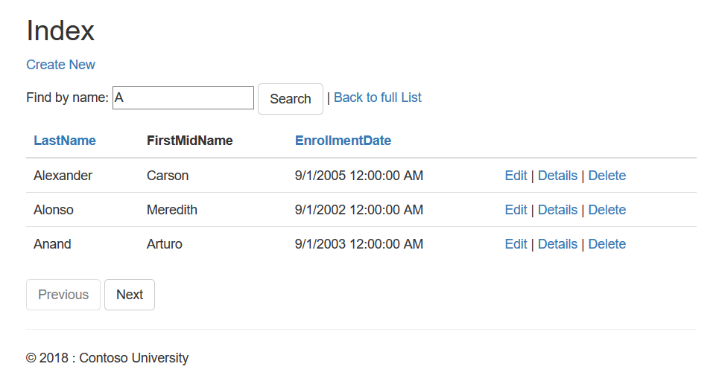

1. Do a screen print of the revised About page showing student enrollment statistics.

